

**ONLINE CRIME REPORTING APPLICATION (E-TIP)**

**A CASE STUDY OF MAKUPA POLICE STATION**

**ROBERT KIPROTICH SANG**

**BSIT/146J/2016**

**SUPERVISOR**

**Mr .HASSAN SHEE**

**Research Project Submitted in Partial Fulfillment for the Degree in Bachelor of Science in Information Technology of Technical University of Mombasa.**

**MAY 2021**

**DECLARATION**

**Declaration by the student**

This project is my original work and has not been presented for a degree in any other University or for any other award.

Name: ROBERT KIPROTICH

Sign: ____________________ Date: _____________

**Declaration by the supervisor**

I confirm that the work reported in this project was carried out by the candidate under my supervision.

Name:Mr. HASSAN SHEE

Sign: ____________________ Date: _____________

# **DEDICATION**

I dedicate this project to my supervisor Mr. HASSAN SHEE

# **ACKNOWLEDGEMENT**

I would like to thank my parents for having had my back financially and emotionally throughout the three-year period, secondly I would want thank my friends for creating that positive habitat that gave me a go head in studying and most importantly I would like thank the Almighty God for the gift of life.

**ABSTRACT**

The proposed project aims to develop an online crime reporting application, that will enable different clients be able to report crimes and security agencies to receive crime reports with the application. The significance of the study is to provide a more efficient system that eases the process of reporting criminal acts and provide a convenient way of keeping these records.

**TABLE OF CONTENTS**

**DECLARATION** i

**DEDICATION** ii

**ACKNOWLEDGEMENT** iii

**ABSTRACT** iv

**TABLE OF CONTENTS** v

**LIST OF TABLES** vii

**LIST OF FIGURES** viii

**LIST OF ACRONYMS AND ABBREVIATIONS** ix

**DEFINITION OF KEY TERMS** x

**CHAPTER ONE: INTRODUCTION** 1

1.1 **Introduction** 1

**1.2 Background of the study** 1

**1.3 Problem statement** 1

**1.4 Objectives of the study** 1

1.4.1 General objectives 1

1.4.2 Specific objectives 1

**1.5 Research question** 1

**1.6 Significance of the study** 2

**1.7 Limitations of the study** 2

**1.8 Scope of the study** 2

**1.9 Organization of the study** 2

**CHAPTER TWO: LITERATURE REVIEW** 3

**2.1 Introduction** 3

**2.2 Theoretical Review** 3

**2.3 Similar Systems** 3

**2.4 Critical review and Research Gap identification.** 4

**2.5 Chapter summary.** 4

**CHAPTER THREE: METHODOLOGY** 5

**3.1 Introduction** 5

**3.2 Research Design** 5

**3.2.1 Target population** 5

**3.2.2 Sample size** 5

**3.2.3 Data collection procedure & instruments** 5

**3.3 System Development methodology** 5

**3.3.1 Methodology Justification** 8

**3.4 System Requirement Analysis** 8

**3.4.1 Functional requirements** 8

**3.4.2 Non-functional requirements** 9

**3.4.3 Modelling Language** 9

**3.5 Database Design** 15

**3.5.1 Table Design** 15

**3.5.2 3NF Normalized form** 15

**3.6 Testing Design** 15

**3.6.1 Test cases** 16

**3.7 Chapter Summary** 16

**APPENDICES: 17**

**APPENDIX 1: REFERENCES 17**

**APPENDIX 2: QUESTIONNAIRE 18**

**APPENDIX 3: BUDGET 20**

**APPENDIX 4: TIMEFRAME 21**

**CHAPTER FOUR: RESEARCH FINDINGS AND DISCUSSION** 22

**4.1 Introduction 22**

**4.2 Presentatio of Findings. 22**

**4.2.1 Objective 1 22**

**4.2.2 Objective 2 etc. 22**

**4.4 Chapter Summary010 22**

**[5.1 Introduction 23**

**5.2 Summary of Findings 23**

**5.2.1 Objective one. 23**

**5.2.2 Objective two, etc. 23**

**5.3 Conclusions 23**

**5.4 Recommendations; should be in line with the study area and the conclusions. 23**

**5.5.5 Suggestions for further study- should be in line or advised by the study processes. 23**

**5.6 Chapter Summary 23**

**REFERENCES 23**

**APPENDICES 23**

**Questionnaire 23**

**Budget 23**

**work plan 23**

**Program code 23**

**Any other evidence, such as pictures. 23**

# **LIST OF TABLES**

table 1.1 questionnaire

table 1.2 budget

table 1.3 time frame.

# **LIST OF FIGURES**

fig 1.0 waterfall model

fig 1.1 use case diagram

fig 1.2 activity diagram

fig 1.3 sequence diagram

fig 1.4 class diagram

fig 1.5 database design

fig 1.6 test cases

# **LIST OF ACRONYMS AND ABBREVIATIONS**

HTML Hypertext Markup Language

CSS Cascading Style sheet

PHP hypertext preprocessor

OMG Object Management Group

UML Unified modelling language

OOAD Object Oriented Analysis and Design

MVC Model View Controller

# **CHAPTER ONE: INTRODUCTION**

1.1 **Introduction**

This chapter will entail the background of the study, the problem statement and objective of the study, research question, and significance of the study, limitation of the study, scope of the study and organization of the study.

## **1.2 Background of the study**

The idea of coming up with a web based crime reporting application is that there are a lot of crimes happening in our community which go unreported not because of negligence of community members but because of inadequate communication platform between the public and the authority.

This will help members of the public to report crimes such as theft, robbery fraud, scam and illegal trade.They will be able to view wanted suspects,stolen items,items recovered by police and missing persons.

The police and directorate of criminal investigations will be able to receive data reported by the citizens.

This will also whistle blowers to report anonymously.

For faster communication the authorized officer will receive data through their mobile phone in form of short message service (sms)

## **1.3 Problem statement**

Crime and suspect human activities have always been part of the society. However, there has been acknowledged increase in crime in Kenya, with most of them not being reported or the reporting done too late. Such cases go unresolved and victims have limited options of acquiring justice. It is essential to have well organized and widely available method for reporting criminal activities to the relevant authorities and support for quick response units. This information needs to be transmitted instantly and remotely without the technical and the cumbersome need to physically access police stations. Web-based application will help members of the public to submit their complains by filling a web form and attaching an evidence if possible, it will also inform members on wanted criminals by displaying their images. This will greatly improve security and safety and pass information to the public.

**1.4 OBJECTIVES OF THE STUDY**

### **1.4.1 General objectives**

To develop an online system that will be able to help members of the public to pass information to the authority easily without going to the police station.

### **1.4.2 Specific objectives**

1. To test the requirements necessary for the development of the system.
2. To test the requirements gathered.
3. To test the system with its user interfaces, logic side and the model side

## **1.5 Research question**

The question that led to this study was why do Kenyan citizens have to go through a challenging process to report crime thus lead to:

1. How will the requirements be gathered?
2. How will the gathered requirements be analyzed?
3. How will the system be designed?
4. How will the system be implemented and tested?

## **1.6 Significance of the study**

The proposed system is meant to target the entire population in Kenya, members of the public must no longer visit the police station in order to report crime and whistle blowers will no longer worry about their identity report anonymously.

## **1.7 Limitations of the study**

The proposed system only targets a Kenyan population and citizens with smartphones. And basic computer knowledge and internet use.

## **1.8 Scope of the study**

The proposed system is restricted to Kenyan citizens, in reporting crimes, it will also utilize internet and messaging as a form of communication

## **1.9 Organization of the study**

The research team will collect relevant information, then determine user and system requirements from these data collected, these will be forwarded to a panel that will document and forward to the system designers. The system designer will then create a layout in conjunction with the database administrator and finally be handed to the programmers.

# **CHAPTER TWO: LITERATURE REVIEW**

## **2.1 Introduction**

This chapter will deal with the theoretical review and the brief information on similar systems and also deal with the system critique and lastly a summary of the chapter.

## **2.2 Theoretical Review**

This section analyzed the current security situation within the city of Mombasa and the improvements that have been made to the situation. Security flaws that have been witnessed in the city have been analyzed and recommendations made on how they would have been avoided and how they can be managed in the future. Technology has been examined to determine how it would have been useful in these situations. There are some challenges that victims face when reporting crimes to the relevant authorities. These challenges have been examined to determine how they can be improved.

**2.2.1 State of Security in Kenya**

Currently, the main source of criminal information and reporting is the reports developed

from the police investigations and occurrence books at the police stations across the country

(Goodrich, 2012). The police often rely on the use of public information to piece together

their investigation. The process of reporting crimes is generally slow in Kenya and

ineffective. Getting through to the designated phone lines is often difficult and faces

numerous technical barriers. Previous studies in the same region have revealed that

corruption is one of the major challenges that have hindered crime-fighting within the

country

**2.2.2Analysis of the Security Forces in Response to Crime Reports**

Security agencies are tasked with the responsibility of conducting the investigations on

criminal activities that have taken place. Statistics indicate that the level of crime often

reduces as the case are being solved. Reporting the criminal activities to the security

agencies is highly dependent on the victims and the means of communication with the

security agencies. The security agencies then initiate the relevant investigations to ensure

that they are completed within the shortest time possible and the culprit is apprehended

(Pokhariyal, Muthuri & Muthuri, 2003).

**2.2.3 Challenges Associated with Crime Reporting in Kenya**

There is a paucity of literature on crime reporting in Kenya. Few studies like (Ruteere and

Pommerolle, 2003) observed that modern way of reporting crimes is through call centers

which have disadvantages like:

•

* A member of the public reporting a crime might make a call and end up not being

attended to since the phone rings for a long time without anyone picking.

•

* A caller might be put on hold for a long time making it possible for the criminals to

get to him/her or even get away before the notice is given to the authorities.

•

* Sometimes it might not be possible to make a call due to the nature of the danger a

victim is in, for example, it could be the victim is among very dangerous robbers

who are armed and any mistake like a call can cost a life.

•

* Calling will require both parties to make a conversation, which might not be very

secretive making it dangerous especially where notifying the authorities requires

very secretive measures.

•

* It does not leave a report in the system just in case a call was not picked but instead

shows a missed call which can be easily assumed.

•

* Network failures sometimes will hinder any successful call.

Reporting in person has several disadvantages too:

By the time the victim reaches the police station, the crime has already been committed

especially where the nearby police station is a bit far.

•

•

* This method of crime reporting is very slow because a lot of time is consumed to

access the police station and give a statement.

•

* Witnesses might not dedicate their time to go to the police station and make a report

probably because of fear, apathy, attending to personal matters or the nearby police

station is very far.

•

* This way of reporting a crime rarely encourages reporter anonymity which is very

important for the security of the member of the public who volunteered to bring the

matter to the attention of the authorities (Sahle, 2012

## **2.4 Similar Systems**

**1. American FBI Submit a Tip system**

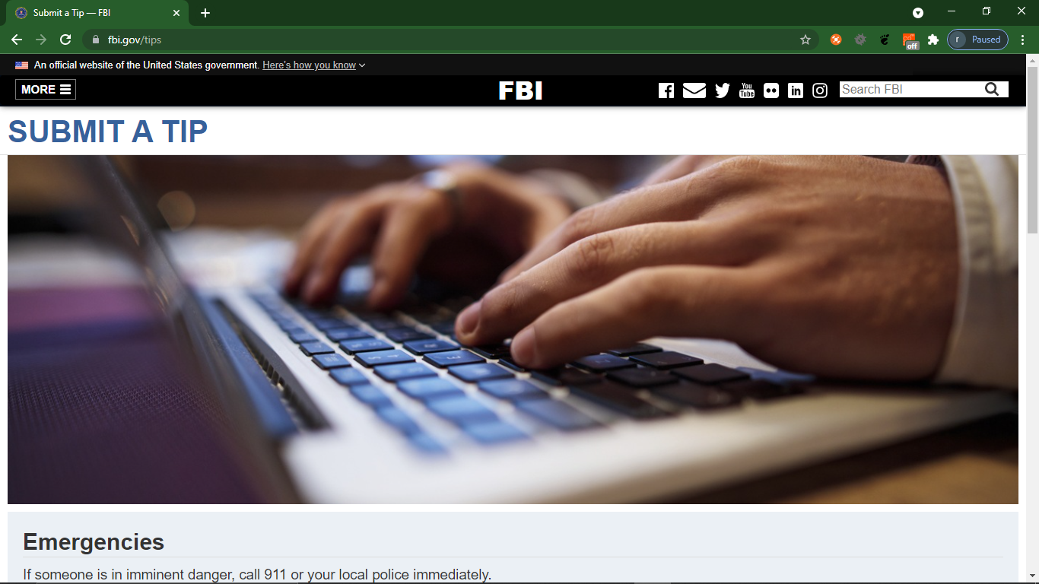

This is a platform where members of the public can report violations of US federal law or suspected terrorism or criminal activity by filling an online web form.The system also has emergency contacts where someone can call when in an emergency eg, fire,ambulance or robbery.However this system does not have a functionality that allow users to attach files as evisence.It also has no sms service hence communication is slow.The above system has no functionality for viewing missing people and stolen items recovered by police

1. **Nigeria police cybercrime reporting portal**

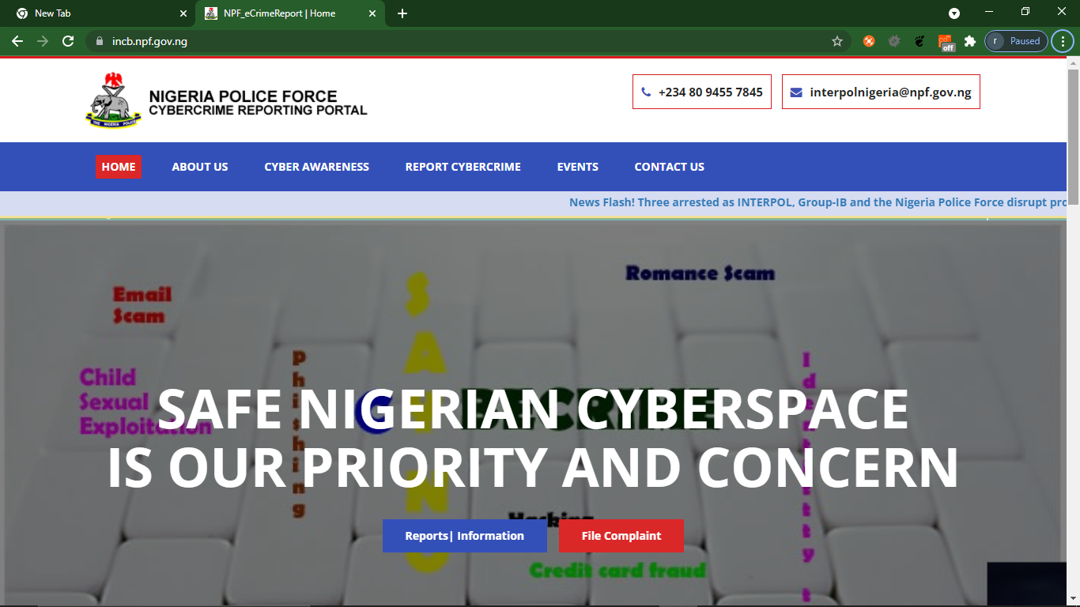

This portal is an initiative of Nigeria Police Force to facilitate victims/complainants to report cyber crime complaints online. This portal caters to complaints pertaining to cyber crimes only. Complaints reported on this portal will be attended to by the police based on the information available in the complaints. It is important that correct and accurate details are provided while filing complaint for prompt action.

This system only deals with cybercrime.Their users have to visit the police station physically to report offence and crime.

## **2.5 CRITICAL REVIEW.**

The proposed project is expected to possess some unique features different from the other similar existing system. One of the features is that it allows the user upload photos as evidence,view and report wanted suspect easily.The system also has sms functionality where reported case are received by the admin as sms.

The system also has functionality that allow reporting of missing persons whwre their details can be seen by members of the public.These details include the missing person photo.

## **2.6Chapter summary.**

Crime reporting has many trust and cooperate issues. With employment of the right technology most of these problems can be mitigated to a great scale and enhance the performance in this sector.

# **CHAPTER THREE: METHODOLOGY**

## **3.1 Introduction**

This chapter is organized and describes research methodologies, research design, target population, data collection, data analysis, data specification validity and reliability of the study UML diagrams and lastly a summary of the chapter(Wang & Salazar, 2016).

## **3.2 Research Design**

This section focuses on how data will be collected and analyzed basing on the specification in the research problem. It outlays the blueprint of how the data and information is to be gathered and analyzed. This study will employ exploratory design that will help determine the best research design, data collection method and selection of subjects.

### **3.2.1 Target population**

The population that is in scope in relation to this study is entire Kenyan citizen as any citizen with access to the internet and a smart device should be able to report case. The same target population will be used for requirement gathering and testing.

### **3.2.2 Sample size**

A sample is a subset of an entire set in this case, population. In the requirements gathering, the study will sample a sizeable number of citizens in a few major cities from all social walks of life. This will result to proportional sample size. They will help to obtain the system requirements and the users’ requirements.

### **3.2.3 Data collection procedure & instruments**

The study will employ the use of questionnaires, interviews, records and experimental approach to gather the requirements. The researcher will schedule for interviews with students and also prepare a number of copies of questionnaires to be administered.

## **3.3 System Development methodology**

(López-Campos et al., 2012)System development methodologies tries to describe a way of developing software. It outlines the steps to plan, design and control the whole process of developing a system. This study intends to use waterfall model for developing the system where it will divide the project into sequential cases with overlap and splash back in case of error. This is a linear model where each activity provides the input to the next stage in the process. (Eom et al., 2007)This process usually has high visibility because at the close of each stage full documentation is generated for that stage. Emphasis will be on planning time schedules target dates, budgets and implementation of the entire system.

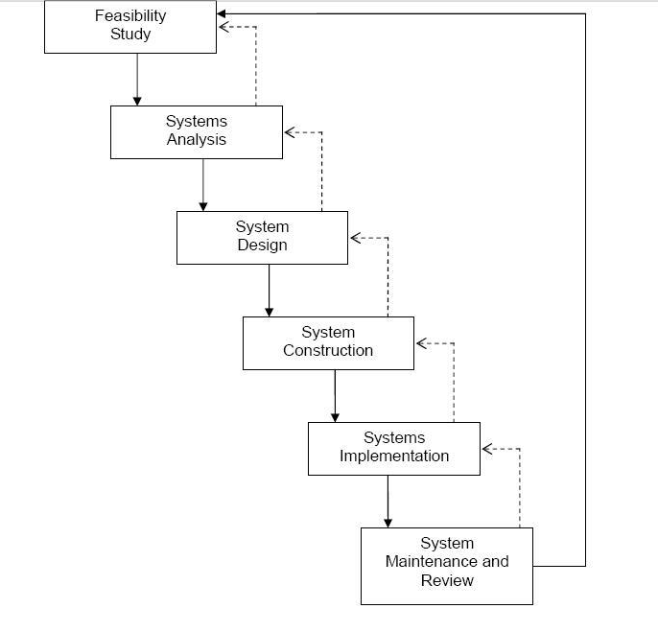

Fig. 1.0 The waterfall model

**Feasibility Study**

This stage tries to find out whether the project is feasible or not. It will look at a number of considerations like technical, personnel and cost issues and examine different ways in which the system can be developed.(Jin et al., 2006) For example – can the system be developed in-house or will outsourcing be required, does the organization have the necessary technical resources and expertise to undertake the project, will the system be of financial benefit to the organization and is the money available to develop it? The output from this phase is a feasibility report, which summarizes the study and makes recommendations about the way forward.

**Systems Analysis**

Once the feasibility study has confirmed that the system can and should be developed, the next phase consists of a detailed investigation of the requirements of the system, invariably involving extensive consultation with the users of the system. If the new system is to replace an old one,(Al-Khaldi et al., 2002) then it is normal to study the existing system in depth so that its objectives, outputs and the exact way in which it works can be understood, as well as identifying any problems associated with it so that these are not repeated. At the same time, it is necessary to find out what new features and functionality should be included in the new system.

**System Design**

This phase takes the requirements specification and converts it into a system design specification. This involves the design of inputs, outputs, databases, computer programs and user interfaces. The design phase is normally split into logical and physical design. Logical design concentrates on the business aspects of the system and is theoretically independent of any hardware or software.(Xu et al., 2017) Physical design takes the logical design specification and applies it to the implementation environment. Most often the choice of programming language and database is already decided and these technologies are taken into account in physical design.

**System Construction**

This phase is where the system is actually built. The system specifications are turned into a working system by writing, testing and, in due course, documenting the programs which will make up the whole system. Once the individual programs have been tested, the whole system needs to be put together and tested as a whole.(Volokhov et al., 2011) This whole phase requires extensive user involvement. The output from this phase consists of detailed program and file specifications which, in total, describe exactly how the new system works.

**Systems Implementation**

The objective of this phase is to produce a fully functioning and documented system. It involves training users, transferring data from the old system to the new and actually putting the new system into operation – "going live". There are a number of different approaches to this, as we shall see later in the course. A final system evaluation will also need to be performed to make sure the system works according to expectatio ns.

**System Maintenance and Review**

During the life of a system, continual review and maintenance will need to be performed in order to maintain its functionality.(Chiang et al., 2006) For example, new requirements may need to be implemented and errors in the system need to be rectified. Such maintenance is really a repetition of the other phases of the life cycle as a new requirement or a fix for an error needs to be analyzed, designed and implemented. Eventually all systems become outdated and need to be replaced, so the cycle starts again, with the way in which the old system is operating and the requirements which now apply forming the backdrop to a new feasibility study to examine whether a new system should be developed.

### **3.3.1 Methodology Justification**

Waterfall models are long used in design research investigations.(Maynard et al., 2005) A review of publications in journal in engineering design report an increase in use and acceptance of waterfall models. Waterfall models can allow for splash back in cases of errors and also projects are shortened.

The Waterfall Model (WM) is an early lifecycle model which is based on engineering practice; it works well if the requirements are well-understood.

Good features:

1. phases are important even if their sequence is not.
2. works for well-understood problems.
3. keeps managers happy.
4. Simple to understand

## **3.4 System Requirement Analysis**

This refer to the specifications that the system should possess for the software or application to work. The system requirements proposed are:

1. I/O ports for listening to server request.
2. Windows operating system.
3. Hard disk size 100GB minimum.
4. Web browser.
5. RAM size of 2GB minimum.

### **3.4.1 Functional requirements**

The study will encompass the tasks that will go into determining the needs or condition to meet a new project taking into account possible conflicting requirements of the various stakeholders, analyzing, documenting, validating and system requirement.

The proposed system shall be able to:

1. To enable users to submit case without login
2. To enable the system admin be able to register and login.
3. To enable users to upload photos of lost items and missing persons.
4. To enable whistle blowers to tip police anonymously.
5. To enable users to view an report wanted suspects.
6. To enable admin to receive notification through sms when case is reported.

### **3.4.2 Non-functional requirements**

The system should be:

1. Easy to use and simple user interface
2. Available when needed for use.
3. Backed up and have a recovery mechanism in case of error.
4. Able to provide the right information to the right user
5. Able to be maintained
6. Able not to fail and ensure data integrity

### **3.4.3 Modelling Language**

The Unified Modelling Language (UML) is a graphical language for visualizing, specifying, constructing and documenting artifacts of software-intensive systems. Specifying, constructing, and documenting artifacts of software intensive systems.(Ramírez-Castillo et al., 2015) UML represents the unification of a number of efforts to build notations for expressing models of Object Oriented Analysis and Design (OOAD) under the auspices of the Object Management Group (OMG). At present, UML is the de-facto standard for Object Oriented modelling. UML is suitable for modeling various kinds of systems examples:

1. enterprise information systems,
2. distributed web-based,
3. real-time embedded system, etc.

#### **3.4.2.1 Use case diagram**

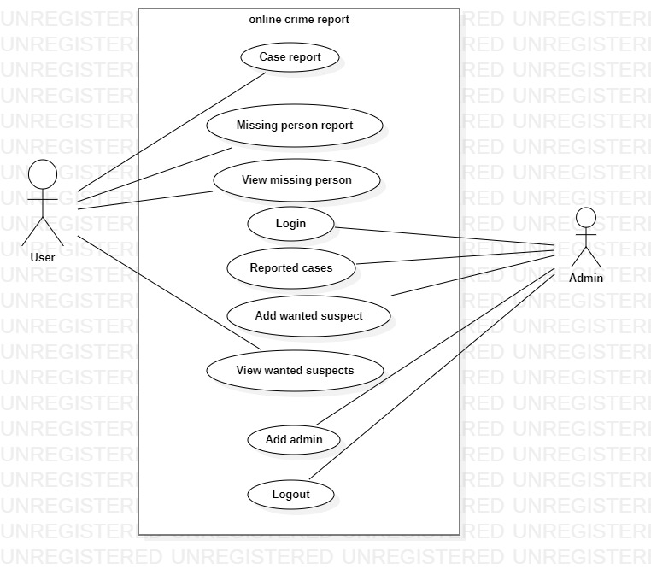

fig 1.1 use case diagram

#### **3.4.2.2 Activity Diagram**

Shows control/data flows from one activity to another.

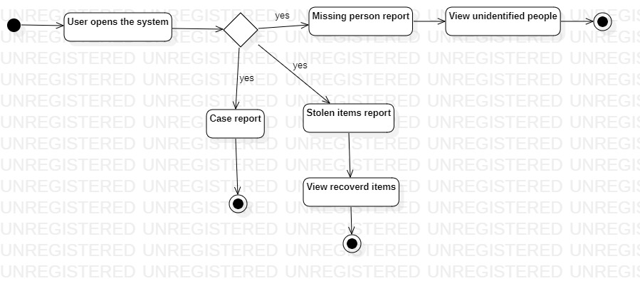

fig 1.2 activity diagram

#### **3.4.2.3 Sequence diagram**

Addresses the dynamic behaviour of a system with special emphasis on the chronological ordering of messages.

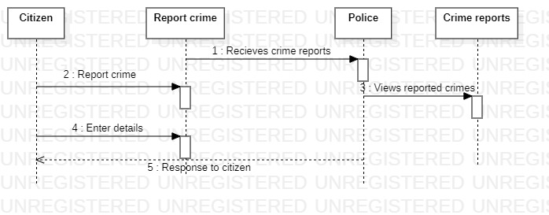

Fig 1.3 sequence diagram

#### **3.4.2.4 Class Diagram**

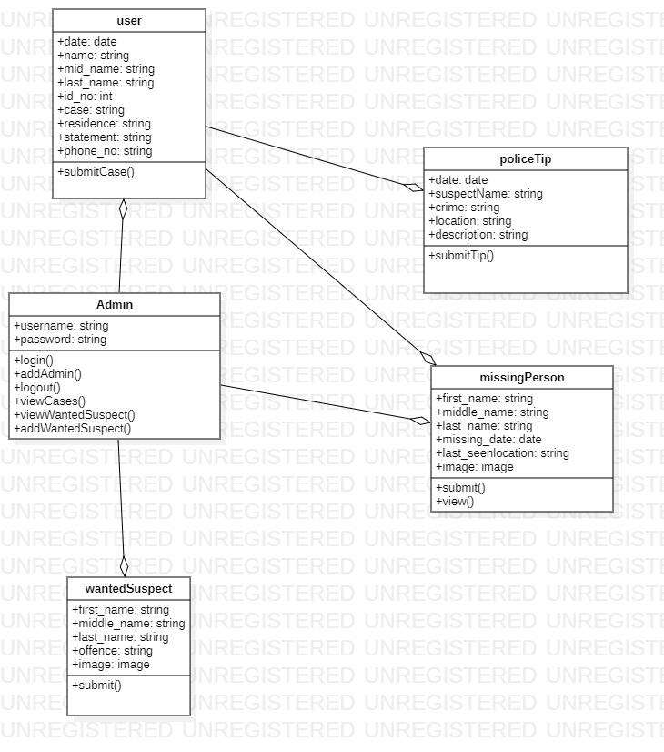

**3.4.2.5 DEPLOYMENT DIAGRAM**

shows configuration of run-time processing nodes and the components hosted on them.

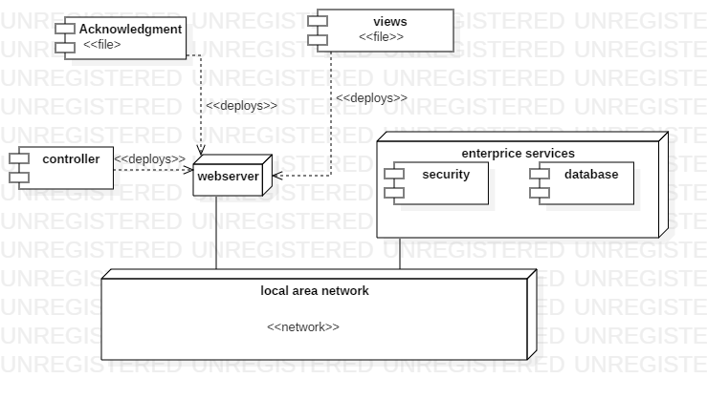 Fig 1.5 deployment diagram

## **3.5 Database Design**

### **3.5.1 Table Design**

**Table 3.5.1.1 Cases table**

|  |  |  |
| --- | --- | --- |
| **Field name** | **Data type** | **constrains** |
| id | Integer | Primary key |
| date | String |  |
| first_name | String |  |
| middle_name | String |  |
| Last_name | String |  |
| Id_no | Integer | Unique key |
| crime | String |  |
| residence | String |  |
| statement | String |  |
| phone | Integer |  |

**Table 3.5.1.2 Missing persons table**

|  |  |  |
| --- | --- | --- |
| **Field name** | **Data type** | **constrains** |
| first_name | integer | Primary key |
| middle_name | string |  |
| phone_number | string | Unique key |
| middle_name | string |  |
| date | string |  |
| residence | string |  |
| statement | string |  |

**Table 3.5.1.3 Stolen items table**

|  |  |  |
| --- | --- | --- |
| **Field name** | **Data type** | **constrains** |
| id | integer | Primary key |
| first_name | string |  |
| middle_name | string |  |
| Last_name | string |  |
| date_stolen | date |  |
| Stolen_item | string |  |
| location | string |  |
| residence | string |  |
| statement | string |  |
| phone | integer | Unique key |

**Table 3.5.1.4 users table**

|  |  |  |
| --- | --- | --- |
| **Field name** | **Data type** | **constrains** |
| id | integer | Primary key |
| username | string |  |
| password | string | Unique key |
| Email | Email | Unique key |

**Table 3.5.1.5 Wanted suspect table**

|  |  |  |
| --- | --- | --- |
| **Field name** | **Data type** | **constrains** |
| date | integer |  |
| name | string |  |
| reward | integer | Unique key |
| offence | string |  |
| hotline | Integer | Unique key |

**Table 3.5.1.6Whistleblower table**

|  |  |  |
| --- | --- | --- |
| **Field name** | **Data type** | **constrains** |
| date | integer | Primary key |
| Suspect_name | string |  |
| crime | string |  |
| location | string |  |
| statement | string |  |

fig 1.6 database design

### **3.5.2 3NF Normalized form**

**Cases table**

|  |  |  |
| --- | --- | --- |
| **id** | **name** | **location** |

**Missing persons table**

|  |  |  |
| --- | --- | --- |
| **id** | **Phone _no** | **residence** |

**Wanted suspect table**

|  |  |  |
| --- | --- | --- |
| **id** | **crime** | **statement** |

**Stolen items table**

|  |  |  |
| --- | --- | --- |
| **name** | **Stolen_item** | **date** |

**Users table**

|  |  |  |
| --- | --- | --- |
| **username** | **password** | **Email** |

**Whistleblower table**

|  |  |  |
| --- | --- | --- |
| **Suspect_name** | **crime** | **location** |

## **3.6 Testing Design**

The proposed system after completion of the development we will test the system using test cases for user testing, system testing and requirements testing after which it will be deployed. The study will carry the following tests using test data and cases(Gopal et al., 2015):

Unit testing – test individual components

Module testing – test related collections of dependent components

Sub-system - Modules are integrated into sub-systems and tested. The focus here should be on interface testing

System testing - testing of the system as a whole. Testing of emergent properties

Acceptance testing - testing with customer data to check that it is acceptable

### **3.6.1 Test cases**

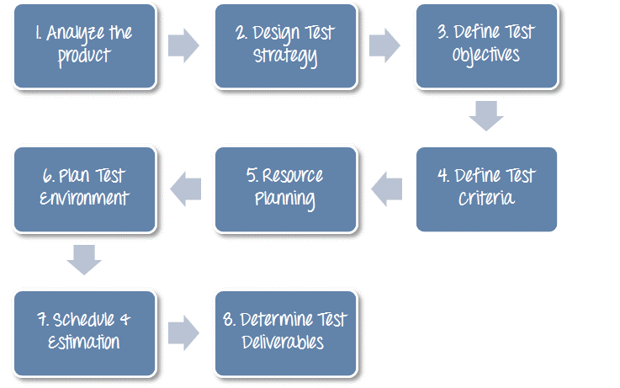 fig 1.7 test cases

## **3.7 Chapter Summary**

This chapter contains and has expounded on the system design focusing on how data will be gathered, analyzed, represented using tables and unified modeling diagrams. Also, it touches on how the test design should be carried out.

# **CHAPTER FOUR: RESEARCH FINDINGS AND DISCUSSION**

## **4.1 Introduction**

This chapter is organized and describes all the presentations and findings that the project proposal has. It explains how each objective was achieved and supplies a screenshot for illustration.

## **4.2 PRESENTATION OF FINDINGS.**

### **4.2.1** **objective 1: requirement gathering**

User requirements were gathered and were divided into two categories:

**4.2.1.1 Functional Requirements**

1. **System specification**
2. Ability of the system to report case easily without login
3. Ability to view stolen items,missing persons and wanted suspects.
4. Ability of the admin to login and create another admin if necessary
5. Ability of the admin(government official ) to generate view all reports concerning all the activities carried out in the system.
   * + - 1. **User Specification**
6. Case reporter – is able to report case and attach evidence in form of image
7. Citizen– is able to view and report wanted suspects,stolen items,missing persons
8. Police – is able to view wanted suspects or add a wanted suspect, add/remove user, view all cases reported.

#### **4.2.1.2 Non-functional requirements**

These are the requirements that are used to describe the operation of the system rather than specific behaviors. They ensure effectiveness and usability of the system (Badiru & Afolabi, 2016).

1. Security – the system is able to provide authorized access to the users before interacting with the system. The users need to register and create an account and their credentials will be stored in the database encrypted.
2. Usability – the system is easy to use since the user interface is friendly, easy and intuitive to understand.
3. Performance – the system has a quick response time that is the refreshing times and loading screen would be faster.
4. Availability – the system will be available 24/7. It will be available for access from any location from an online platform.
5. Flexibility – the system is ready for expansion and changes

### **4.2.2 Objective 2: Requirement Analysis**

The requirements which were gathered were later sorted, plotted and correlations were identified. There were divided into user requirements and system requirements.

### **4.2.3 Objective 3: System design**

The system is designed to have three different users i.e user(citizen).government official and admin.

The system has different modules that are accessed with different privileges and different users. It entails the authentication module login page(admin), registration pages, online case reporting,view wanted suspects ,missing persons and stolen items module

**4.2.4 Objective 4: System development**

**4.2.4.1 Admin login page**

The Login page has text fields for Username and password and a login button. Basically, the admin has to enter their registration login details and then proceed by clicking/tapping the login button. It also has a forget password button to reset password in case a user forgets their passwords.

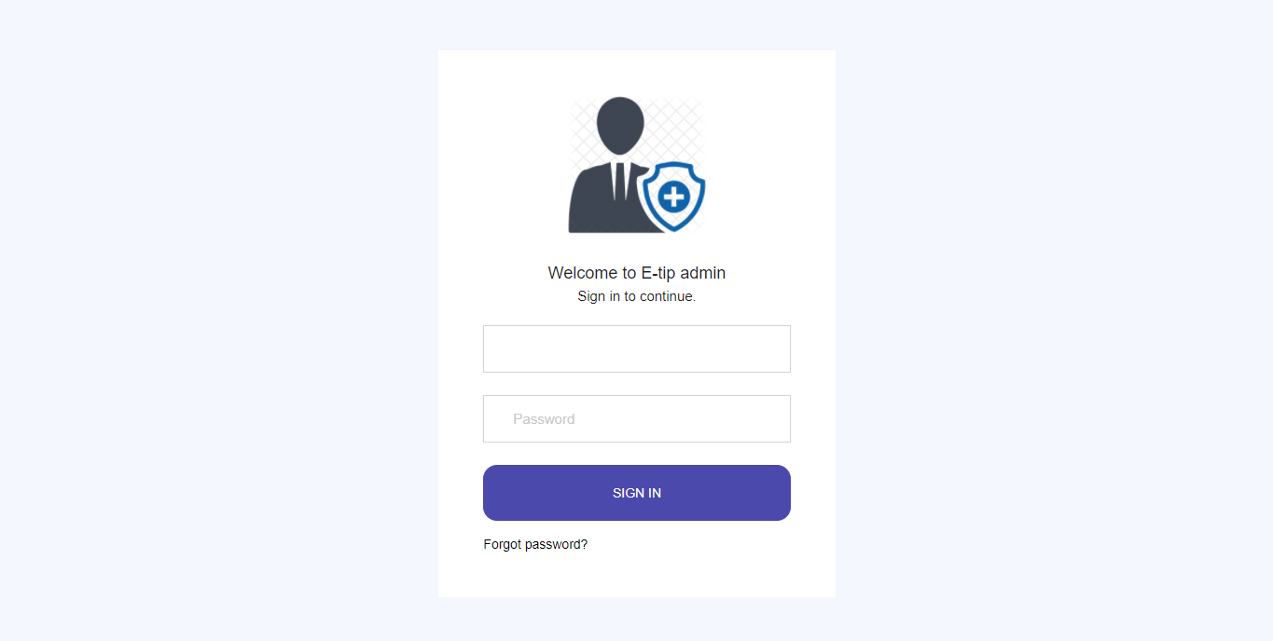

**4.2.4.2 Data Entry Form**

The case report page has text fields for entering details on the case being reported. Basically, the user has to enter the details and then proceed by clicking/tapping the send button.

The user will receive a success message after the details are successfully submitted.

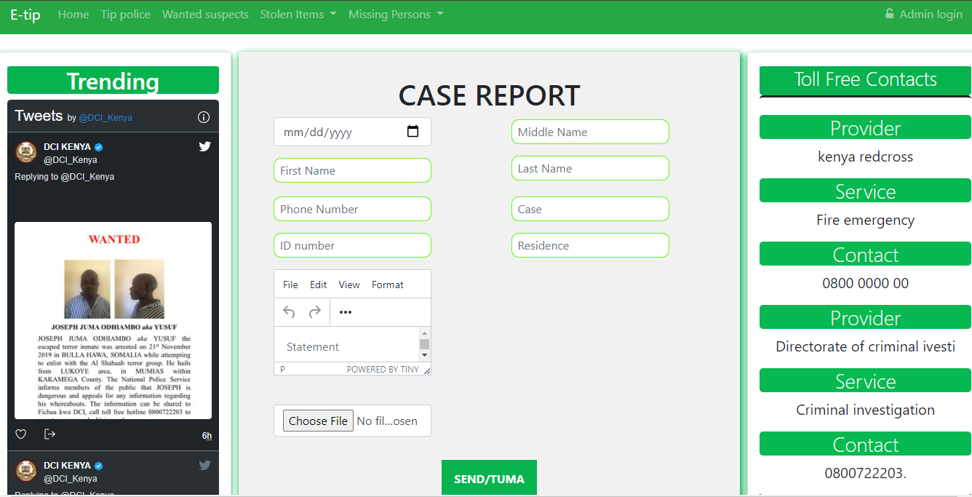

#### **4.2.4.3 Query output screenshots**

This include the snapshots that show the preview of data after it has been requested from the database. For instance, can view all wanted suspects that have been uploaded.

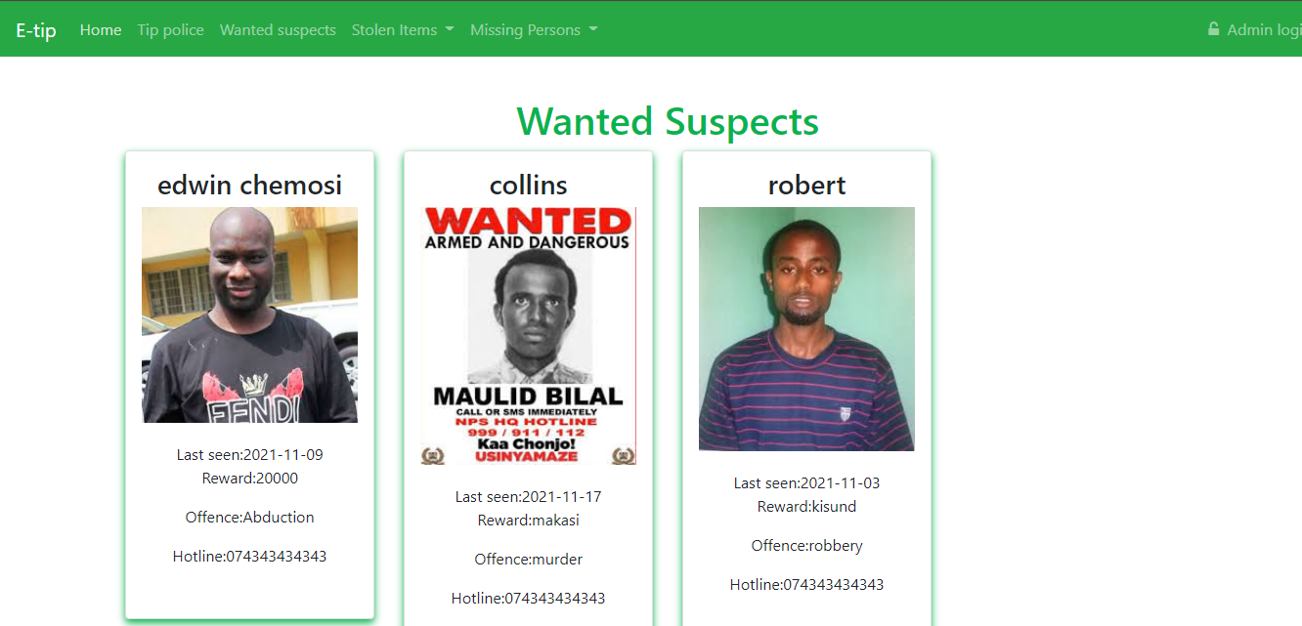

#### **4.2.4.4 Reports screenshots**

This snapshot shows an example of what the admin views as reports from the system. He /she can see

All cases that have been reported.

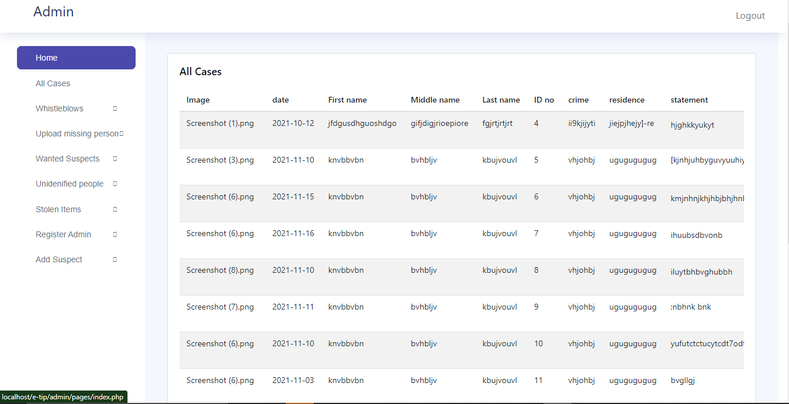

## **4.4 Chapter summary**

This chapter has explained the various system issues including the stages from the requirements gathering up to when the system was developed. It points out the various aspects and items concerning the system and snapshots are also included to describe further the process.

# **CHAPTERFIVE:SUMMARY, CONCLUSIONS AND RECOMMENDATIONS**

## **Introduction**

This chapter summarizes the finding of the study and makes conclusions upon which recommendations are drawn. Suggestion for further study is also captured as a way of filling the gaps identified in the study. The chapter also summarizes the findings of the current method of the system and whether to adopt the use of online platform to conduct all the processes of reporting case, viewing reported cases and many other more.

## **5.2 Summary of Findings**

## **5.2.1 Objective 1: Requirements gathering**

The project proposal realized that the farmers were really in need of an online platform and the idea was welcomed by many. the farmers and all the stakeholders were willing to offer their requirements and suggested how they expected the system to behave.

### **5.2.2 Objective 2: Requirement analysis**

The gathered data was then analyzed using the qualitative and quantitative techniques. There were requirements for the system and the requirements for the users which were further subdivided into functional and non-functional requirements

**5.2.3 Objective 3: System design**

Systems design is the process of defining elements of a system like modules, architecture, components and their interfaces and data for a system based on the specified requirements (Casmir et al., 2013).

Using the unified modelling language, the system was designed pointing out the various modules and interfaces with the users who will interact with them. Every action was taken into consideration and assigned the interface on which it will take place.

The modelling languages include deployment diagram, use cases, activity and sequence diagrams

**5.2.4 Objective 4: System development**

The project proposal implemented the system using HTML, PHP , CSS and Javascript.

Below are some of the codes to illustrate the same:

**Case submission class**

if(isset($_POST['submit_case'])){

$date = $conn->real_escape_string($_POST['date']);

$fname = $conn->real_escape_string($_POST['fname']);

$mname = $conn->real_escape_string($_POST['mname']);

$lname = $conn->real_escape_string($_POST['lname']);

$idno = $conn->real_escape_string($_POST['idno']);

$crime = $conn->real_escape_string($_POST['crime']);

$residence = $conn->real_escape_string($_POST['residence']);

$statement = $conn->real_escape_string($_POST['statement']);

$phone= $conn->real_escape_string($_POST['phone']);

$targetDir = "admin/images/cases/";

if(!empty($_FILES["file"]["name"])){

$image = basename($_FILES["file"]["name"]);

$targetFilePath = $targetDir . $image;

$fileType = pathinfo($targetFilePath,PATHINFO_EXTENSION);

// Allow certain file formats

$allowTypes = array('jpg','png','jpeg','gif','pdf');

if(in_array($fileType, $allowTypes)){

// Upload file to server

if(move_uploaded_file($_FILES["file"]["tmp_name"], $targetFilePath)){

$sql = "INSERT INTO cases(date,fname,mname,lname,idno,crime,residence,statement,phone,image) VALUES('$date','$fname','$mname','$lname','$idno','$crime','$residence','$statement','$phone','$image')";

}}}

if($conn->query($sql)==true){

$_SESSION['status']="data inserted succesfully";

header('location: index.php');

}

else{

array_push($notify," Could not able to execute $sql. " . $conn->error);

}

$conn->close();

}

**View cases class**

function getCases(){

global $conn;

$data = "SELECT date,fname,mname,lname,id,crime,residence,statement,phone,image FROM cases";

$result=$conn->query($data);

$dt

if($result->num_rows>0){

while($row = $result->fetch_assoc()) {

$image= $row['image'];

$date=$row['date'];

$fname= $row['fname'];

$mname= $row['mname'];

$lname= $row['lname'];

$id= $row['id'];

$residence= $row['residence'];

$statement= $row['statement'];

$phone= $row['phone'];

$crime= $row['crime'];

}

echo $dt.

}

return false;

}

## **5.3 Conclusions**

Data was collected and gathered using various tools which included administering of questionnaires, holding interviews, documents and records and surveys. This methods and techniques exhaustively collected all the required user and systems’ requirements

The collected data was organized and analyzed so as to group the requirements and represent them in a form that can be understood. The requirements were analyzed using the qualitative and quantitative data analysis approaches that grouped the requirements into user requirements and system requirements

The system was then designed according to the analyzed data. The system was designed to have different modules for all the users and admin whereby the activities done by any of the users is only controlled and viewed by the government official and only the results can be universal. The system has separate databases for the different type of information submitted, different views from the database depending with the access controls in the system.

After the whole process of analysing and designing, the process of development was ready. The project proposal implemented the system using HTML, ruby on rails web framework, CSS, Javascript and PHP , Visual studio code (vs code), chrome browser was used to facilitate the coding and testing

## **Recommendations**

There is need to invest more in food security and promoting agriculture in the country and thus the government through the respective stakeholders should develop and adopt the use of automated system. Advancement in use of online and secure systems as such will make the people to obtain and access easily the farm product, foodstuffs and other related products. An automated system will reduce workload and encourage transparency and reduce vices in the agriculture docket of the country.

The following are the recommendations in order to advance this automation and make it impact the lives of many:

1)Improve the system to incorporate and be accessible by any interested partner in the country and beyond.

2) Improve the security measures of the system to protect it from hackers who may exploit the users of the system

## **5.5 Suggestions for further study**

The scope of the study being vast for future implementation, the system can be updated in the future considering new user requirements at the time. The system is flexible and can be easily expanded. The following can be recommended for the future scope of the project:

1)Collect user requirements from different user all around the country to get a large variety of requirements

2)Involve the Directorate of criminal investigation and research to find out what is the best for online case reporting

3)Use of reporting and analytical tools to generate reports and statistics about the system and the users.

## **5.6 Chapter Summary**

This chapter has comprehensively illustrated the findings, the recommendation and the conclusion of the study. The nature of the study is fully understood from the implementation point of view and the suggested recommendation can help improve the system to an effective and efficient tool and solution to the concerned stakeholders.

**APPENDICES**

**APPENDIX 1: REFERENCES**

* Al-Khaldi, S. F., Martin, S. A., Rasooly, A., & Evans, J. D. (2016). Online hiring and booking technologies with respect to time: minireview. Journal of AOAC International, 85(4), 906–910.
* Aw, T. G., & Rose, J. B. (2012). Detection of fraud in online transcations: from phylochips to qPCR to pyrosequencing. Current Opinion in Cryptotechnology, 23(3), 422–430.
* Chiang, Y.-C., Yang, C.-Y., Li, C., Ho, Y.-C., Lin, C.-K., & Tsen, H.-Y. (2006). Identification of Bacillus spp., Escherichia coli, Salmonella spp., Staphylococcus spp. and Vibrio spp. with 16S ribosomal DNA-based oligonucleotide array hybridization. International Journal of Food Microbiology, 107(2), 131–137.
* Eom, H. S., Hwang, B. H., Kim, D.-H., Lee, I.-B., Kim, Y. H., & Cha, H. J. (2007). Multiple detection of food-borne pathogenic bacteria using a novel 16S rDNA-based oligonucleotide signature chip. Biosensors and Bioelectronics, 22(6), 845–853.
* Gopal, N., Hill, C., Ross, P. R., Beresford, T. P., Fenelon, M. A., & Cotter, P. D. (2015). The prevalence and control of Bacillus and related spore-forming bacteria in the dairy industry. Frontiers in Microbiology, 6, 1418.
* Jin, D.-Z., Wen, S.-Y., Chen, S.-H., Lin, F., & Wang, S.-Q. (2006). Detection and identification of intestinal pathogens in clinical specimens using DNA microarrays. Molecular and Cellular Probes, 20(6), 337–347.
* Kim, T.-H., Park, J., Kim, C.-J., & Cho, Y.-K. (2014). Fully integrated lab-on-a-disc for nucleic acid analysis of food-borne pathogens. Analytical Chemistry, 86(8), 3841–3848.
* Lee, D.-Y., Shannon, K., & Beaudette, L. A. (2016). Detection of bacterial pathogens in municipal wastewater using an oligonucleotide microarray and real-time quantitative PCR. Journal of Microbiological Methods, 65(3), 453–467.
* López-Campos, G., Martínez-Suárez, J. V., Aguado-Urda, M., & López-Alonso, V. (2012). Bioinformatics in Support of Microarray Experiments. In Microarray Detection and Characterization of Computer bugs (pp. 49–92). Springer.
* Maynard, C., Berthiaume, F., Lemarchand, K., Harel, J., Payment, P., Bayardelle, P., Masson, L., & Brousseau, R. (2015). Payment gateway application based on paypal, mastercards. Appl. Environ. Microbiol., 71(12), 8548–8557.
* Ramírez-Castillo, F., Loera-Muro, A., Jacques, M., Garneau, P., Avelar-González, F., Harel, J., & Guerrero-Barrera, A. (2015). Online pathogens: detection methods and challenges. bugs and viruses, 4(2), 307–334.
* Rasooly, A., & Herold, K. E. (2018). Application of Microarray Technologies for Crypto Analysis. In Nano and Microsensors for Chemical and Biological Terrorism Surveillance (pp. 116–165). Royal Society of Chemistry.
* Volokhov, D. V., Kong, H., Herold, K., Chizhikov, V. E., & Rasooly, A. (2011). Car hiring technology with real-time responce. In Technological Microarrays (pp. 55–94). Springer.
* Wang, Y., & Salazar, J. K. (2016). Culture-independent rapid detection methods for real time transactions. Comprehensive Reviews in online transaction safety, 15(1), 183–205.
* Xu, M., Wang, R., & Li, Y. (2017). Electrochemical biosensors for rapid detection of Escherichia coli O157: H7. Talanta, 162, 511–522.

## **APPENDIX 2: QUESTIONNAIRE**

**Table 1.0 questionnaire**

|  |  |  |  |  |  |  |
| --- | --- | --- | --- | --- | --- | --- |
| No. | Questions | Strongly Disagree | | Agree | Strongly Agree | |
| 1 | I think that I would trust the system on my privacy |  |  |  |  |  |
| 2 | I found the system unnecessarily complex |  |  |  |  |  |
| 3 | I thought the system was easy to use |  |  |  |  |  |
| 4 | I think I’ll need assistance to use the system |  |  |  |  |  |
| 5 | I liked the integration of components |  |  |  |  |  |
| 6 | I think the system has lots of inconsistency |  |  |  |  |  |
| 7 | I imagine many people will find the system easy to use |  |  |  |  |  |
| 8 | I found the system cumbersome and awkward to use |  |  |  |  |  |
| 9 | I felt confident using the system |  |  |  |  |  |
| 10 | I need to learn many things before I could start using the system |  |  |  |  |  |

## 

## **APPENDIX 3: BUDGET**

**Table 1.1 budget**

|  |  |
| --- | --- |
| Item | Estimated cost(Ksh.) |
| Internet expenses | 6000.00 |
| Web hosting and domain | 4000.00 |
| Online research | 2000.00 |
| Support software costs | 1000.00 |
| Research process cost | 6000.00 |
| **TOTAL** | **20000.00** |

## **APPENDIX 4: TIMEFRAME**

**Table 1.2 timeframe**

|  |  |  |  |  |  |  |
| --- | --- | --- | --- | --- | --- | --- |
| No. | Activity | September | October | November | December | January |
| 1 | System & User requirement |  |  |  |  |  |
| 2 | Physical Design |  |  |  |  |  |
| 3 | Logical Design |  |  |  |  |  |
| 4 | Coding |  |  |  |  |  |
| 5 | Testing |  |  |  |  |  |
| 6 | Presentation and report writing |  |  |  |  |  |
| 7 | Documentation |  |  |  |  |  |